ROSE MEMORIAL LIBRARY ASSOCIATION

79 East Main Street, Stony Point, New York 10980

Regular Meeting of the Board of Trustees
Wednesday, November 15, 2017
6:30 pm

AGENDA

I. Call to Order
II. Adoption of Minutes:
Regular Meeting, September 20, 2017 *
Regular Meeting October 18, 2017 *
Special Meeting, November 13, 2017 *

III. Public Comment INTRODUCTION OF GUESTS
IV.. Friends of the Library

V. Finance – Report Narrative
Approval of Disbursements: month ending October 31, 2017 *
Financial Reports for October 2017 *

VI. Reports
- Director
- Report
- Board Committees -
- Building/Capital Projects – Report on Old School Project
- Finance & Budget - Preparation of 2018 Operating Budget
3. Policy -
4. Planning – Hamilton raffle - selling strategy
Hamilton Day - Jan 11 drawing event
5. Technology

VII. Old Business

VIII. New Business

1. Auditor’s Report - Berard & Associates – 2016 Audit Report *

2. Adoption of Holiday Closing Schedule 2018*

3. Resolution to approve the RCLS 2018 Budget*
http://www.rcls.org/?q=node/257

4. Resolution to approve the renewal of the ANSER Agreement*
http://www.rcls.org/anser/2013-2017%20ANSER-Agreement.pdf

IX. Executive Session *

X. Adjournment *
*=motion required
Next Scheduled Meeting:
Wednesday, December 20, 2017 @ 6:30 P.M.

11.14.17

ROSE MEMORIAL LIBRARY ASSOCIATION

79 East Main Street, Stony Point, New York 10980

Regular Meeting of the Board of Trustees
Wednesday, September 20, 2017
6:30 pm

Minutes
Attendees: Jennifer Lima, Terry Marsico, Christina Mandara, Rebecca Sanders, Theodore Needleman, Michele Rinaldi, (6) James Mahoney (Director)

I. Call to Order at 6:38pm by Ms. Lima

II. Adoption of Minutes:

Motion to approve the Regular Meeting Minutes for June 20, 2017 with correction by Ms. Lima, 2nd by Mr. Marsico, Motion passed.
Motion to approve the Regular Meeting Minutes for July 19, 2017 with corrections by Mrs. Mandara, 2nd by Ms. Sanders, Motion passed.
Motion to approve the Special Meeting Minutes for September 14, 2017 by Ms. Sanders, 2nd by Ms. Lima, Motion passed.
Accept the record of the Special Meeting held on August 16, 2017 as not representing a quorum of the Board by Ms. Rinaldi, 2nd By Mrs. Mandara.

III. Public Comment - None

IV.. Friends of the Library – Per the Director’s report we have seen an increase in the number of people who would like to volunteer with the Library. These individuals should be recruited for the Friends group and facilitation of the PAC committee.

V. Finance – Report Narrative – Ms. Sanders and Mr. Mahoney met this past week to review the financial plan.

Motion to Approve the Disbursements: month ending September 30, 2017 and
Financial Reports for September 2017 by Ms. Rinaldi, 2nd by Mr. Needleman, Motion passed.

VI. Reports

- Director
- Report reviewed by the Board

- Board Committees -

- Building/Capital Projects – Report on status of Old School Project.
- Finance & Budget – A meeting will be set for the committee to meet pending results of the audit.
3. Policy - Discussion on revising bylaws to decrease Board size back to 7 members.
4. Planning – None
5. Technology - None

VII. Old Business - None

VIII. New Business
1. Discussion and decision made by board on logo for Library based on several examples sent by Communication Services.

IX. Executive Session *

Motion made by Ms. Lima, 2nd by Mrs. Mandara to exit Regular Board meeting and enter Executive Session at 7:00 pm. Robert Schofield, Esq joined by Phone.

Review and Discussion of letter received from the Town Clerk, Joan Skinner, rejecting the Library’s submission of petitions to have a 414 Referendum proposition places on the Nov. 7th ballot
Motion made to authorize Library Counsel to commence special proceedings to challenge the Town Clerk’s decision to block the petitions submission to the Rockland County Board of Elections by Ms. Rinaldi, 2nd by Mr. Needleman. Motion Passed by 5 members, 1 opposed, 0 abstained.

Motion made to adjorn Executive committee and return to the Regular Board Meeting at 8:10pm.

X. Adjournment

Motion to adjourn meeting made at 8:38pm by Mrs. Mandara, 2nd by Ms. Sanders. Motion passed.

Next Scheduled Meeting:
Wednesday, October 18, 2017 @ 6:30 P.M.

Revised 11.15.17

ROSE MEMORIAL LIBRARY ASSOCIATION

79 East Main Street, Stony Point, New York 10980

Regular Meeting of the Board of Trustees
Wednesday, October 18, 2017
6:30 pm

Minutes

Attendees (5): Jennifer Lima, Terry Marsico, Christina Mandara, Theodore Needleman, Rebecca Sanders, James Mahoney (Director).

Absent (1): Michele Rinaldi

I. Call to Order by Jennifer Lima at 6:45pm

II. Adoption of Minutes:
Regular Meeting September 20, 2017 – unavailable – approval pending until next Regular Board Meeting

III. Public Comment - None

IV.. Friends of the Library – no update

V. Finance – Report Narrative

Discussion of cash flow projections based on timing of receipt of school and town funds. Mr. Mahoney also explained the status of the Merrill Lynch account funds (See Financial Report). We need to plan on spending some of these funds due to timing of public funds and expenses due to legal fees and initial building projects.

Approval of Disbursements: month ending September 30, 2017 *
Financial Reports for September 2017 *

Motion to approve the Disbursements and Financial reports for month ending September 30, 2017 made by Mr. Needleman, 2nd by Ms. Sanders. Motion passed unanimously (5/0)

VI. Reports

- Director
- Report
We are in need of technical support and routine maintenance on all of the computers. Mr. Mahoney is asking a new Tech Company to update the public computers and make sure they sync with the printers, etc.

- Board Committees -
- Building/Capital Projects – Report on Old School Project

- Finance & Budget – A meeting time has been set for the committee to meet with the accounting firm on November 1st at 7pm. Goal to have the budget prepared in November so the Board will have time to review for the December Regular Board meeting.
3. Policy – no update
4. Planning – Mrs. Mandara discussed a plan by the Stony Point Taxpayers for a New Library and the Friends of the Library to develop a “Books to Broadway” fundraising initiative, led by a pair of tickets to a Broadway performance of “Hamilton”.
5. Technology - See Director Report

VII. Old Business - None

VIII. New Business
1. Auditor’s Report – (See Finance and Budget Committee) – Mr. Mahoney submitted boilerplate descriptions of the functions and goals of the Library for the audit, but has not seen the final report yet. Presume it will be reviewed at the 11/1/17 committee meeting and presented to the Board on the 11/15/17 Regular Board meeting.
2. Proposed change to Personnel Policy – Work Schedules *
Auditors suggested expanding the policy (see attached) to detail the hours worked versus breaks, and lunches based on the total number of hours worked.

Motion made to accept the proposed changes to the Personnel Policy: “Work schedules” by Mrs. Mandara, 2nd by Ms. Sanders. Motion passed unanimously (5/0)

- Plan to invite people who are interested in being a Trustee to the November Board meeting.
- Hole in book drop needs to be repaired. Mr. Marsico knows someone who can fix it.
- Review of letter to be sent to Town Supervisor and Town Council asking them to please not pass the Town Budget prior to Election Day just to prevent our receiving funding in 2018 if the vote passes in 2017. In the last 7 years the budget was not passed prior to Election Day, except in 2012.

IX. Executive Session *

Motion made by Ms. Lima, 2nd by Mr. Needleman to enter into executive session for legal matters at 9:09pm. Motion passed unanimously (5/0)

Motion to close Executive session made by Ms. Lima, 2nd. By Mr. Needleman, at 9:17pm.
Re-enter regular meeting. Motion passed unanimously (5/0)

X. Adjournment *

Motion to adjourn made by Mrs. Mandara, 2nd by Mr. Marsico. Motion passed unanimously (5/0)

*=motion required
Next Scheduled Meeting:
Wednesday, November 15, 2017 @ 6:30 P.M.

11.10.17

ROSE MEMORIAL LIBRARY ASSOCIATION

79 East Main Street, Stony Point, New York 10980

Special Meeting of the Board of Trustees
Monday, November 13, 2017
7:00 pm

Minutes

Attendees: Jennifer Lima, Christina Mandara, Theodore Needleman, Terry Mascico, Rebecca Sanders, James Mahoney (Director) (5)
Absent: Michele Rinaldi (1)

I. Call to Order at 7:09 pm by Ms. Lima

II. Public Comment – Mr. John Brenner, resident and former head of the Stony Point Democratic Committee attended to explain the absentee ballot counting timeline and system, the definition of over/under votes, and the process for having a Board member present at the counts, if needed. Mr. Brenner also explained what happened on election day with the mix-up of the voter registration books, ballots, and scanning machines for Kirkbride Hall and Immaculate Conception School polling centers being delivered to the wrong places, which necessitated the collection of about 100 affirmation ballots. The Board was very appreciative of this information.

III. New Business
RESOLUTION
Upon a motion made by Theodore Needleman and seconded by Terry Marsico it was
RESOLVED, that the President of the Board of Trustees is authorized and directed, in consultation with the Library’s counsel, to cancel the Contract of Sale for 117 W. Main Street, entered into between the Library (as Purchaser) and Egor Zharkov (as Seller), no later than November 15, 2017 if, in the President’s sound discretion, it is not clear that the Stony Point Proposition #4 has passed as a result of the Rockland County Board of Election’s absentee ballot canvass to commence on November 14, 2017.
Ayes: 5 Nays: 0 Abstentions 0
IV. Executive Session - None

V. Adjournment *

Motion to Adjourn made at 8:00pm by Ms. Lima, 2nd by Mr. Needleman

Next Scheduled Meeting:
Wednesday November 15 , 2017 @ 6:30 P.M.
11.13.17
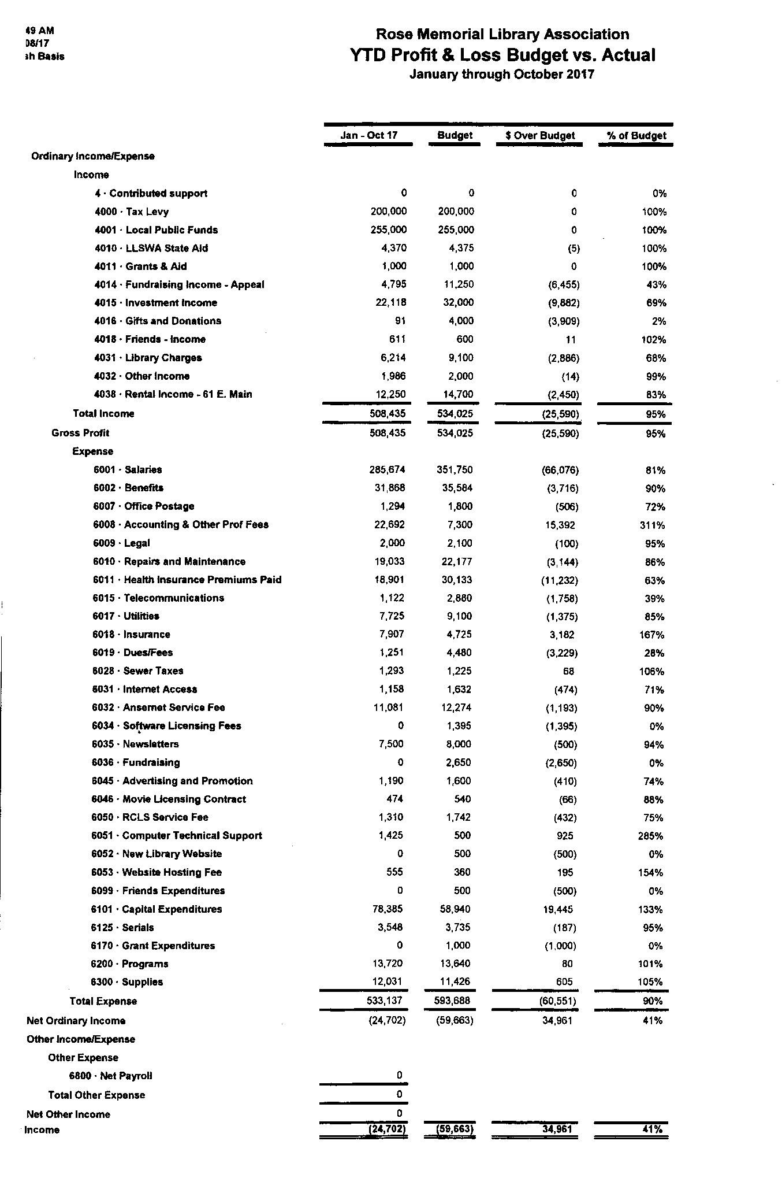

Rose Memorial Library
Financial Report
November 14, 2017
We began the year in January with operating funds of $114,426, and after all the pluses and minuses in the past ten months we had $143,988 in our TD Bank operating account as of 11/8/17. Last year, at 11/1/16 we had $182,653 left in our operating account.

Revenue YTD was $508,435, 95% of budgeted amount.

Two revenue lines seem to be falling short this year: Library charges ($6,214) at 68% of budget, compared to $7,563 in YTD 2016. Investment Income is also below budget ($22,118) at 69%, compared to $26,303 in 2016.

In the past ten months we spent $533,137 from our budget, representing 90% of budgeted expenses. We shall be exceeding expenses in certain categories as the year progresses. In the month of October there were 3 payrolls on the month of October ($44,900), architects fees ($10,368), 2 health insurance payments ($4,288); over $9,000 for communications and marketing services; attorney ($4,390); automation ($6,057).

Our Merrill Lynch Cash Account started at $189,380 and has been reduced now to $7,269 due to the deposit of $140,000 on the Old School and transferring $75,000 to the operating account. The remaining Merrill Lynch Bonds and Cash funds have a value of $479,802.

Our operating account will carry us through December 31st, but we shall be considerably over budget. I estimate that in addition to the normal operating expenses in November and December we will have the potential for extraordinary expenses of another $65,000.

James Mahoney
Library Director
November 14, 2017

CALENDAR OF LIBRARY CLOSINGS
2018

Monday January 1 New Year’s Day
Sunday April 1** Easter**
Monday May 28 Memorial Day
Wednesday July 4 Independence Day
Monday September 3 Labor Day
Wednesday November 21 Thanksgiving Eve (Close at 5PM)
Thursday November 22 Thanksgiving
Monday December 24 Christmas Eve (Close at 2 pm)
Tuesday December 25 Christmas Day
Monday December 31 New Year’s Eve (Close at 2 pm)

With the exception of Easter Sunday** all full-time staff will be paid for the above 6 full-day closings and 2 half-day closings. (Part-time staff whose normal schedule would include any of these days will receive pro-rated holiday pay).

The Library will remain open on the following holidays, but staff will have the option of taking the day off, or working their shift at the premium rate of time and a half and earning a floating holiday Substitutes will also be offered the premium rate.

Monday January 15 Martin Luther King Jr Day
Monday February 19 Presidents’ Day
Monday October 8 Columbus Day
Sunday November 11 Veteran’s Day
Friday November 23 Day after Thanksgiving

Floating holidays need to be coordinated with coverage requirements and approved by the Director at least 30 days in advance. Floating holidays will expire in 180 days.

Regular hours: Monday through Thursday 10 am – 9 pm
Friday 10 am – 7 pm
Saturday 10 am – 5 pm
Sunday 1 pm – 5 pm

