A Remembrance Message from State Comptroller Thomas DiNapoli
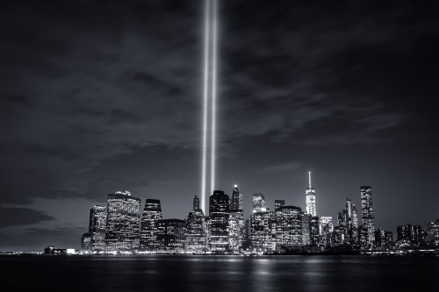

Friday was a day of remembrance and reflection for the souls that perished on September 11, 2001 in Shanksville, Washington and, of course, lower Manhattan. So hard to believe it was 19 years ago.
We will never forget the tragic loss of life, the bravery of our first responders. Equally, we won’t forget how New Yorkers and our nation pulled together in the throes of such devastation and heartbreak on 9/11 and helped each other heal.

To all our in Stony Point community: I was asked to publish a tribute to all of those lost in the 9/11 tragedy, and I came across this message. It seems as fitting, and honorable in their remembrance, as we all might commend..
James Mahoney
Library Director
Rose Memorial Library

